Rev. Dr. Martin Luther King, Jr.
National Holiday Breakfast
Hosted by No Place for Hate - Falmouth

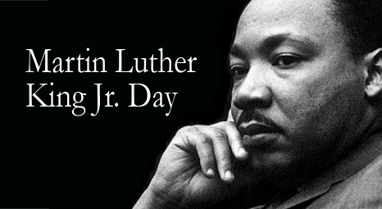

Monday, Jan. 15, 2024 · 9 - 11 am
Sea Crest Resort, North Falmouth

$30 adults / $15 students*
Deadline for advance ticket sales is January 11.
Purchase tickets at the NPFH-Falmouth web site
and learn how to pay by check at:
www.npfhfalmouth.org
Space is limited. Tickets will be sold at the door
only if space is available for $35 adults/$20 students.

Speaker: MANUEL FERNANDEZ
Chief Equity Officer, Cambridge Public Schools, and DEIB Leader
“Fostering Equity and Inclusion in the Community”

Includes special presentation to Jewel Cobb Action Coalition, recipient of the No Place for Hate Civic Leadership Award

Live music, good food & conversation.

Hosted by No Place for Hate – Falmouth, a community-based organization whose purpose is to build bridges to combat bias and to promote respect for all people through education and advocacy. Like us on Facebook. * Please contact No Place for Hate - Falmouth if you require financial assistance to attend.

