Rev. Dr. Martin Luther King, Jr.
National Holiday Breakfast
Hosted by No Place for Hate - Falmouth

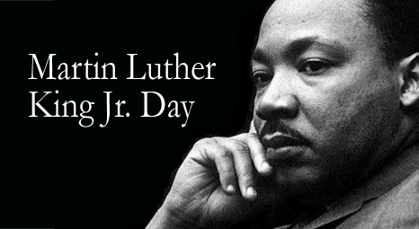

Monday, January 16, 9:15 - 11:00 A.M.
Sea Crest Resort, North Falmouth

$25 adults / $15 students*
Deadline for advance ticket sales is January 11.
Purchase tickets at the NPFH – Falmouth web site and learn how to pay by check at:
www.npfhfalmouth.org
Space is limited. Tickets will be sold at the door
only if space is available for $30 adults/$20 students.

Speaker: HENRY ST. JULIEN, Director of Diversity, Equity, Inclusion, and Belonging, Falmouth Public Schools

Includes a special presentation to the Woods Hole Diversity Advisory Committee, recipient of the No Place for Hate – Falmouth Civic Leadership Award

Live music, good food & conversation.
Collecting these donations for the Falmouth Service Center:
Apple juice (64oz.), pancake mix, canned chicken, ketchup, juice boxes, baby wipes

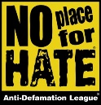 Hosted by No Place for Hate – Falmouth, a community-based organization whose purpose is to build bridges to combat bias and to promote respect for all people through education and advocacy. Like us on Facebook. * Please contact No Place for Hate - Falmouth if you require financial assistance to attend.

